SPECIAL THANKS TO

William E. Thro of the University of Kentucky for chairing the Journal of Education Finance Outstanding Article of the Year Award along with committee members Barbara De Luca, University of Dayton, and Henry Tran, University of South Carolina.

Philip T. Westbrook of the University of Alabama for chairing the NEFA Outstanding Dissertation of the Year Award along with committee members Scott Sweetland, the Ohio State University; Jeffrey Maiden, University of Oklahoma.

To William J. Fowler, Jr. & Patricia R. Fowler for their generous contribution supporting the Education Finance Policy Research Grant to focused on solving applied education finance and budgeting problems.

Kern Alexander for assisting with all collaboration components associated with NEFA and the Journal of Education Finance.

Spencer C. Weiler and Christine Rienstra Kiracofe for organizing all components of the State of the States.

Alexander Stoetzer for his volunteer support associated with the logistics and management of the NEFA Annual conference and launching our first Guidebook Conference App.

Philip T. Westbrook for graciously taking the time and energy to chair and facilitate the NEFA conference workshop focused on teaching school finance.

To the anonymous members of the 2019 National Education Finance Academy Distinguished Research & Practice Fellow Awards Committee, the Nominations Committee, NEFA Lifetime Achievement Award Committee, and the William J. & Patricia R. Fowler, Jr. Education Finance Policy Research Grant Committee.


THANK YOU TO OUR SPONSORS:

Association of Metropolitan School Districts
St. Paul, MN
Illinois State University
Journal of Education Finance
Moak, Casey, & Associates
Old Dominion University
Stetson University
University of North Carolina at Chapel Hill
University of Rhode Island
University of South Florida
University of Tennessee
BOARD OF TRUSTEES

PRESIDENT
Lisa G. Driscoll, University of Tennessee

PRESIDENT-ELECT
Nicola A. Alexander, University of Minnesota
VICE-PRESIDENT
Robert C. Knoeppel, University of South Florida

IMMEDIATE PAST-PRESIDENT
R. Anthony Rolle, University of Rhode Island
BOARD MEMBERS: 2016-2019 TERM
Lisa Dawn-Fisher, DawnFisherWorks
Scott Sweetland, The Ohio State University
William E. Thro, University of Kentucky

BOARD MEMBERS: 2017-2020 TERM
Barbara De Luca, University of Dayton
William A. Owings, Old Dominion University
Gabriel R. Serna, Michigan State University

BOARD MEMBERS: 2018-2021 TERM
Eric Houck, University of North Carolina at Chapel Hill
Lenford Sutton, Illinois State University
Philip T. Westbrook, University of Alabama

GENERAL COUNSEL
Luke M. Cornelius, University of North Florida

WEDNESDAY, April 24, 2019
8:00 a.m. – 5:00 p.m. Conference Registration
11:00 a.m. – 12:30 p.m. Concurrent Session I
1:30 p.m. – 3:00 p.m. State of the States
3:15 p.m. – 5:45 p.m. General Session
6:00 p.m. – 8:00 p.m. Welcome Reception

THURSDAY, April 25, 2019
7:00 a.m.– 8:30 a.m. Journal of Education Finance Breakfast (by invitation)
8:00 a.m. – 5:00 p.m. Conference Registration
8:30 a.m. – 10:00 a.m. Conference Workshop
10:10 a.m. – 11:40 a.m. Concurrent Session II
1:15 p.m. – 2:45 p.m. Concurrent Session III
3:00 p.m. – 4:30 p.m. Concurrent Paper Session IV
4:40 p.m. – 6:10 p.m. Concurrent Paper Session V
6:15 p.m. – 8:00 p.m. Grand Reception

FRIDAY, April 26, 2019
8:30 a.m. – 10:00 a.m. Concurrent Session VI
10:10 a.m. – 11:45 a.m. NEFA Membership and Board of Advisors Business Meeting

2019 NEFA DISTINGUISHED
RESEARCH AND PRACTICE FELLOW AWARDS

Dr. Philip T. Westbrook
Philip T. Westbrook serves as Professor of Educational Leadership at The University of Alabama where he teaches courses in education finance, law, supervision, and curriculum leadership. He has served as a public school teacher, assistant principal, principal, and assistant superintendent. He is a graduate from Birmingham-Southern College, The University of Alabama at Birmingham, and Vanderbilt University. This is his 29th year in public education and his 11th at UA. He currently serves on the Board of NEFA and was a charter member of the organization.

Dr. Luke M. Cornelius
Luke M. Cornelius is a professor and director of Higher Education Administration at the University of North Florida, specializing in Law, Finance, & Policy. He is the founder of the HEA program at UNF and was previously at UNLV and University of West Georgia, as well as teaching History for ten years in the Florida College System. He is the author of numerous books, articles, chapters, and monographs. He holds degrees from Washington & Lee University, the University of Georgia, the University of Florida, and the Georgia State University College of Law. He is a member of the Florida Bar and serves as the General Counsel of NEFA.

2019 NEFA DISTINGUISHED
RESEARCH AND PRACTICE FELLOW AWARDS

Dr. Neil Theobald
Neil Theobald is Vice President for Finance and Administration at the University of Wyoming. Previously, he served as President of Temple University and Vice President & Chief Financial Officer of Indiana University. He also held tenured faculty appointments at the University of Washington, Temple University, and Indiana University, where he directed a research center that worked with five state legislatures on the design of their K-12 education funding formulas. He has published more than 40 academic studies in peer reviewed journals and edited books during his career and received over $6 million in competitive grant funding.

Dr. Margaret L. Plecki
Dr. Margaret Plecki is Professor Emerita in the Area of Educational Foundations, Leadership and Policy at the University of Washington, Seattle. She earned her Ph.D. from the University of California at Berkeley. Her research and teaching expertise focus on school finance, state education policy, educational leadership, educational equity, teacher retention and mobility, and mixed methods research design. Dr. Plecki serves as the Director of the Center for the Study of Teaching and Policy. In addition to her academic experience, she also has worked as a special education teacher and a school district administrator.

Concurrent Session I
Wednesday, April 24; 11:00 a.m. – 12:30 p.m.

1.1 Roundtable P-12
Room: Seattle

FRANK AYATA, Pennsylvania State University; Fiscal Impact of the Charter School Tuition Calculation Turmoil: Investigating Pennsylvania's Resource Allocation Methods

CHANNA BYERLY, University of Oklahoma; The Impact of the Four-Day School Week and District Financial Decisions on Teacher Turnover
(Co-Author: JEFFREY MAIDEN, University of Oklahoma)

1.2 Paper Fowler Fellow Presentation
Room: West Seattle

Chair: R. ANTHONY ROLLE, University of Rhode Island

DELIA B. ALLEN, Riley Institute at Furman University; Rural School Leaders and Discretionary Funds: A mixed methods perspective of school level spending decisions

Concurrent Session I
Wednesday, April 24; 11:00 a.m. – 12:30 p.m.

1.3 Paper Higher Ed.
Room: Adams

Chair: ALEXANDER STOETZER, University of North Florida

MISTY SOLES, Clemson University; Spending Patterns Among College Football Playoff Contenders

ALEXANDER STOETZER, University of North Florida; Is Free Speech Really Free?
(Co-Author: LUKE CORNELIUS, University of North Florida)

1.4 Paper Higher Ed.
Room: Rainier

Chair: JANICE FRIEDEL, Iowa State University

MAUREEN W. MCCLURE, University of Pittsburgh; Hollywood or Bust: By the Time I Get to Phoenix - a Comparative Analysis of Factors Influencing Attrition in the California Education System
(Co-Author: ANNA PETERS, Arizona State University and LOU L. SABINA, Stetson University)

HODA MOHAMED, Michigan State University; Management Excellence and Funding of U.S Research Universities
(Co-Author: GABRIEL R. SERNA, Michigan State University)

Concurrent Session I
Wednesday, April 24; 11:00 a.m. – 12:30 p.m.

1.5 Paper P-12
Room: Baker

Chair: NICOLA ALEXANDER, University of Minnesota

OSCAR JIMENEZ-CASTELLANOS, Santa Clara University; The Politics of K-12 Local Control Funding and Accountability for Latinx and ELL students: Lessons Learned from California
(Co-Author: PATRICIA LOPEZ, Fresno State University and MARIELENA RIVERA, Texas State University)

DAVID G. MARTINEZ, University of South Carolina; English Language Learner Scale in Arizona: A Proportional Funding Analysis

1.6 Paper P-12
Room: Bellevue I

Chair: CHRISTOPHER MULLIN, Strong Start to Finish

EMILY PARKER, Education Commission of the States; K-12 Special Education Funding, 50-State Comparison

Concurrent Session I
Wednesday, April 24; 11:00 a.m. – 12:30 p.m.

1.7 Paper P-12
Room: Bellevue II

Chair: WILLIAM OWINGS, Old Dominion University

HENRY TRAN, University of South Carolina, Columbia; Where do we go from here: How will SC districts respond after the dismissal of Abbeville vs. SC?
(Co-Author: MAZEN AZIZ, University of South Carolina, Columbia and SARA FRAKES REINHARDT, University of South Carolina, Columbia)

SPENCER C. WEILER , University of Northern Colorado; I Can't Get No Satisfaction: An Examination of School Finance Litigation's Influence on State Aid for Publication Education Over 65 Years in States with High and Low Teacher Satisfaction
(Co-Author: CHRISTINE RIENSTRA KIRACOFE, Purdue University and JASON KOPANKE, University of Northern Colorado)

State of the States
Wednesday, April 24; 1:30 p.m. – 3:00 p.m.

State of the States Roundtables
Room: Bellevue

Representatives from each state listed below will discuss current developments in their state. Discussion points will be directed to the following points:

→Funding Priorities for P-12 and/or Higher Education
→Changes to Funding Formula for P-12 and/or Higher Education
→Pressing State Issues Affecting P-12 and/or Higher Education Funding
→Exclusive to P-12: Forces Diverting Funds from Traditional Public School Districts and/or Exclusive to Higher Education: Trends in State Funding for Public Institutions

Co-Chairs:
SPENCER C. WEILER, University of Northern Colorado
CHRISTINE RIENSTRA KIRACOFE, Purdue University

STATE | PRESENTERS
Alabama | PHILIP T. WESTBROOK
Alaska | AMY DAGLEY
Arizona | DAVID MARTINEZ
Arkansas | STEVE BOUNDS
California | HENRY TRAN, OSCAR JIMENEZ-CASTELLANOS & MAZEN AZIZ
Colorado | MICHAEL COHEN & LEE MORGAN
Connecticut | LESLEY DENARDIS
Delaware | LEE MORGAN & MICHAEL COHEN
Florida | LOU SABINA
Georgia | DAVID BUCKMAN
Hawaii | BRENDA MENDIOLA
Illinois | LEN SUTTON
Indiana | CHRISTINE RIENSTRA KIRACOFE
Iowa | JAN FRIEDEL
Kentucky | BILL THRO
Louisiana | VENICE ADAMS
Maryland | CHELSEA LYLES
Massachusetts | TYRONE BYNOE
Michigan | BRETT GEIER
Minnesota | NICOLA ALEXANDER
Mississippi | SPENCER STONE
Missouri | CAMERON ANGLUM
Montana | KIARA SABINA
Nebraska | BARBARA LACOST
Nevada | DEBORAH VERSTEGEN &  OSCAR JIMENEZ-CASTELLANOS
New Hampshire | SCOTT SWEETLAND
New Jersey | LUKE STEDRAK
New Mexico | DAVID MARTINEZ
New York | OSNAT ZAKEN
North Carolina | WALTER HART
Ohio | RANDY VESELY
Oklahoma | JEFFREY MAIDEN &  CHANNA BYERLY
Oregon | JASON KOPANKE
Pennsylvania | MATTHEW KELLY & FRANK AYATA
South Carolina | HENRY TRAN & MAZEN AZIZ
South Dakota | TAMMIE REYNOLDS &  JEFF MAIDEN
Tennessee | LISA DRISCOLL
Texas | KEN HELVEY
Utah | ARVIN JOHNSON
Vermont | FRANK AYATA, MATTHEW KELLY & JEREMY ANDERSON
Virginia | BILL OWINGS & LESLIE KAPLAN
Washington | JASON KOPANKE
West Virginia | DREW MILLIGAN & RICK FERRIS
Wyoming | NEIL THEOBALD

General Session
Wednesday, April 24; 3:15 p.m. – 5:45 p.m.
Room: Lake Washington Ballroom

Welcome

NEFA President’s Address
Lisa G. Driscoll, NEFA President

NEFA Distinguished Research & Practice Fellow Awards
Presented by Lisa G. Driscoll, NEFA President

William J. & Patricia R. Fowler Education Finance Policy Research Grant
Presented by William J. Fowler and R. Anthony Rolle, NEFA Immediate Past-President

Election and Nominating Procedures for New Officers
Presented by Nicola A. Alexander, NEFA President-Elect

Constitution and By-Law Changes
Robert C. Knoeppel, NEFA Vice President

Eulogies
Eugene P. McLoone
Kern Alexander, University of Illinois, Urbana-Champaign

David S. Honeyman
Christopher Mullin, Strong Start to Finish

The Legacy of McCleary

Panelists
To Be Announced

Conference Remarks
Carlee Escue Simon, NEFA Executive Director
Welcome Reception.
Wednesday, April 24; 6:00 p.m. – 8:00 p.m.

Room: Lake Washington Ballroom and Pre-function

SPONSORED BY
UNIVERSITY OF RHODE ISLAND
COLLEGE OF EDUCATION

Journal of Education Finance Breakfast
Thursday, April 25; 7:00 a.m. – 8:30 a.m.
By Invitation Only

Room: West Seattle
Conference Workshop
Thursday, April 25; 8:30 a.m. – 10:00 a.m.

Teaching School Finance
Room: Lake Washington Ballroom

Chair: Philip T. Westbrook, University of Alabama

Panelists:

Steve Bounds, Arkansas State University
Lisa Driscoll, University of Tennessee
Brenda Mendiola, University of Alabama
Spencer C. Weiler , University of Northern Colorado

Although the specific content for teaching school finance will vary from state to state, through the sharing of ideas, it is the purpose of this workshop for participants to leave with new ideas for their own teaching. This workshop will be a collaborative work session designed for both facilitators and participants to share ideas to enhance the teaching of school finance. The discussion will cover master’s degree to advanced studies. The topics of engagement will include:
• major topics taught,
• various formats of content delivery,
• ways to engage students,
• assignment/activity ideas,
• evaluation methods, and
• NEFA support
Participants please come prepared to engage in the discussion by sharing your ideas, thoughts, and questions.

Concurrent Session II
Thursday, April 25; 10:10 a.m. – 11:40 a.m.
2.1 Roundtable Higher Ed.
Room: Seattle
JOANN ELLIS, Florida Gulf Coast University; Budget Allocation and Campus Security: Where is the line?
(Co-Author: JENNIFER SUGHRUE, Florida Gulf Coast University)

AMBER HUNT, University of Mount Union; The Effects of Higher Education Funding Allocations on University Budget Development and Management

2.2 Symposia P-12
Room: Bellevue II
Chair: NEIL THEOBALD, University of Wyoming

The Third Wave after Three Decades: Reflections on School Finance Litigation

WILLIAM E. THRO, University of Kentucky
R. CRAIG WOOD, University of Florida
CHRISTINE RIENSTRA KIRACOFE, Purdue University

Concurrent Session II
Thursday, April 25; 10:10 a.m. – 11:40 a.m.

2.3 Paper Higher Ed.
Room: Adams

Chair: ANTHONY ROLLE, University of Rhode Island

LINDA COLLINS, U.S. Government Accountability Office; Public Service Loan Forgiveness: Education Needs to Provide Better Information for the Loan Servicer and Borrowers (GAO-18-547)

BRIAN SCHWARTZ, U.S. Government Accountability Office (GAO); The Department of Education's Oversight of Default Rates and Default Management Strategies (GAO-18-163)

2.4 Paper P-12
Room: Renton Club
Chairs: IRIS BENDAVID-HADAR, Bar Ilan University, Israel

LISA G. DRISCOLL, University of Tennessee; Unpacking the Adequacy II Standard
(Co-Author: ROBERT C. KNOEPPEL, University of South Florida)

Concurrent Session II
Thursday, April 25; 10:10 a.m. – 11:40 a.m.

2.5 Paper P-12
Room: Rainier

Chair: SHARDA JACKSON-SMITH, University of South Carolina Upstate

DAVID KNIGHT, University of Texas at El Paso; Does the Measurement Matter? Assessing Alternate Approaches to Measuring State School Finance Equity for California's Local Control Funding Formula
(Co-Author: JESUS MENDOZA, City of El Paso)

DAVID G. MARTINEZ, University of South Carolina; Undermining Self-Determination Through Mandated Educational Compliance.
(Co-Author: VICTOR BEGAY, North Idaho College)

2.6 Outstanding Dissertation Award Winner
Room: Bellevue I

Chair: PHILIP T. WESTBROOK, University of Alabama

PAKETHIA HARRIS, University of South Florida; Money Matters: An Examination of Special Education Characteristics in Efficient and Inefficient Texas School Districts

Concurrent Session III
Thursday, April 25; 1:15 p.m. – 2:45 p.m.

3.1 Roundtable Higher Ed.
Room: Seattle

JANICE FRIEDEL, Iowa State University; Five Core Themes to consider when designing a statewide tuition-free college initiative
(Co-authors: BELLINDA ASSEMIEN, Iowa State University)

CHELSEA LYLES, Virginia Polytechnic Institute and State University; The Effects of Responsibility-Centered Management on Engineering Faculty Salaries

3.2 Symposium P-12
Room: Bellevue II

Chair: DAVID KNIGHT, University of Texas at El Paso

She Said, He Said, She Said: Re-Exploring the Influences of Equity, Efficiency, and Adequacy in Education Finance

R. ANTHONY ROLLE, University of Rhode Island
NICOLA ALEXANDER, University of Minnesota
GLORIA RODRIGUEZ, University of California – Davis

Concurrent Session III
Thursday, April 25; 1:15 p.m. – 2:45 p.m.
3.3 Paper Higher Ed.
Room: Adams

Chair: JOANN ELLIS, Florida Gulf Coast University

RICK FERRIS, University of Charleston; The Making of the Grade: Title IV and Institutional Fiscal Health Scores

CHRISTOPHER MULLIN, Strong Start to Finish; Understanding Impact: A Holistic Return on Investment Framework for Developmental Education

3.4 Paper P-12
Room: Renton Club

Chair: AMBER HUNT , University of Mount Union

MATTHEW KELLY, The Pennsylvania State University; The implementation of funding formula changes and racially disparate allocations of state aid: Evidence from Pennsylvania
(Co-Author: FRANK AYATA, The Pennsylvania State University)

TONI TEMPLETON, University of Houston; Principals as Mitigators of Teacher Incentive Pay
(Co-Authors: CATHERINE L. HORN, University of Houston and DINA GHAZZAWI, University of Houston)

Concurrent Session III
Thursday, April 25; 1:15 p.m. – 2:45 p.m.
3.5 Paper P-12
Room: Rainier

Chair: HENRY TRAN, University of South Carolina

JASON KOPANKE, University of Northern Colorado; The Temporal Effects of the Third Wave of School Finance Litigation on Per-pupil Funding

WILLIAM E. THRO, University of Kentucky; Avoiding a Constitutional Crisis: Reflections on Judicial Remedies in School Finance Litigation

3.6 Paper P-12
Room: Bellevue I

Chair: TYRONE BYNOE, University of Michigan – Flint

NICOLA ALEXANDER, University of Minnesota; Does school finance policy matter? The associations among progressivity of school funding systems, economic inequality, and the distribution of student scores
(Co-Author: HYUNJUN KIM, University of Minnesota)

SHARDA JACKSON SMITH, University of South Carolina Upstate; Economic Indicators in Florida's Education Funding Formula: Reconsidering Income through a Correlation Examination

Concurrent Session IV
Thursday, April 25; 3:00 p.m. – 4:30 p.m.

4.1 Roundtable P-12
Room: Seattle
Chair: OSNAT ZAKEN, Touro College

IRIS BENDAVID-HADAR, Bar Ilan University, Israel; Does Equitable Funding Affect the Equality of Educational Opportunity? The Case of the Israeli Periphery

TAMMIE REYNOLDS, University of Oklahoma; The Relationship Between Capital Outlay Funding Inequities and General Education Resources
(Co-Author: JEFFREY MAIDEN, University of Oklahoma)

TYRONE BYNOE, University of Michigan – Flint; A Case Study of Recent Michigan School Finance Adequacy Analyses and Policy Recommendations

Concurrent Session IV
Thursday, April 25; 3:00 p.m. – 4:30 p.m.
4.2 Paper P-12
Room: Bellevue II
Chair: CHRISTINE RIENSTRA KIRACOFE, Purdue University

ERIC HOUCK, University of North Carolina at Chapel Hill; Left Behind: District Secession and the re-segregation of American Schools
(Co-Author: BRITTANY MURRAY, University of North Carolina at Chapel Hill)

DEBORAH VERSTEGEN, University of Nevada Reno; Paying the Piper: New findings from a 50-state survey of state school finance systems
(Co-Author: ROBERT C. KNOEPPEL, University of South Florida)

4.3 Paper Higher Ed.
Room: Adams
Chair: DAVID REEPING, Virginia Polytechnic Institute and State University
GABRIEL SERNA, Michigan State University; Budget Stabilization Funds and Higher Education Funding: Does Countercyclical Policy Impact State Support?
(Co-Author: JOSHUA M. COHEN, University of North Dakota)
NEIL THEOBALD, University of Wyoming; From the Mountains to the Ocean: A Foreboding Two State Analysis of Higher Education Finance and Tuition Discounting
(Co-Author: R. ANTHONY ROLLE, University of Rhode Island)
Concurrent Session IV
Thursday, April 25; 3:00 p.m. – 4:30 p.m.
4.4 Paper P-12
Room: Renton Club
Chair: DUSTIN ROBINSON, University of South Florida

J. CAMERON ANGLUM, University of Pennsylvania; Which School Districts Are Credit Constrained in Their Efforts to Invest in School Infrastructure? Evidence from a Natural Experiment

CARLEE ESCUE SIMON, University of Florida; State Constitutional Mandates and School Facilities
(Co-Authors: SPENCER C. WEILER, University of Northern Colorado and MARK PAIGE, University of Massachusetts- Dartmouth)

4.5 Paper P-12
Room: Rainier

Chair: JASON KOPANKE, University of Northern Colorado

MAUREEN MCCLURE, University of Pittsburgh; Local Public Governance, Truncated State Views, and Conflicts in the Political Economy

WILLIAM OWINGS, Old Dominion University; Misconceptions: What Politicians, and the Public are Getting Wrong About Education Finance
(Co-Author: LESLIE KAPLAN, Old Dominion University)

Concurrent Session IV
Thursday, April 25; 3:00 p.m. – 4:30 p.m.

4.6 Paper P-12
Room: Bellevue I

Chair: JOHN OLERIO, University of Rhode Island

KRISTINE BOWMAN, Michigan State University; States' Interventions into School Districts' Finances
(Co-Author: DIRK ZUSCHLAG, Michigan State University)

DAVID G. MARTINEZ, University of South Carolina; The Mediating Effects of Education Spending on Achievement in Arizona

Concurrent Session V
Thursday, April 25; 4:40 p.m. – 6:10 p.m.

5.1 Roundtable P-12
Room: Seattle
DUSTIN ROBINSON, University of South Florida; Blaine Amendments: The Constitutionality and Financial Implications of Relinquishing Government aid to Non-Secular Educational Institutions

CLAY WEBBER, University of Alabama; A Quantitative Study of The Equity and Efficiency of Alabama State Educational Expenditures From 2007 To 2017

5.2 Symposium P-12
Room: Renton Club

Chair: MATTHEW KELLY, The Pennsylvania State University

LOU L. SABINA, Stetson University; How Are We Teaching Educational Finance? An Analysis of Course Syllabi from Graduate Institutions
(Co-Authors: ANNA PETERS, Arizona State University and MAUREEN W. MCCLURE, University of Pittsburgh)

Concurrent Session V
Thursday, April 25; 4:40 p.m. – 6:10 p.m.

5.3 Paper Higher Ed.
Room: Rainier

Chair: RICK FERRIS, University of Charleston

JOHN OLERIO, University of Rhode Island; An Analysis of Factors That Predict Timely Undergraduate Degree Completion

DAVID REEPING, Virginia Polytechnic Institute and State University; The Credit Hour Economy: Agent-Based Modeling of Responsibility Centered Budget Management Effects
(Co-Author: GABRIEL R. SERNA, Michigan State University

5.4 Paper Higher Ed.
Room: Bellevue I

Chair: NICOLA ALEXANDER, University of Minnesota

CHRISTOPHER NEARY, Iowa State University; Higher Education PBF Policy and Taxonomy: Tying higher education performance-based funding measures to state budgeting taxonomies
(Co-Author: JANICE FRIEDEL, Iowa State University)

NEIL THEOBALD, University of Wyoming; The Impacts and Sustainability of Tuition Discounting at Public Universities
(Co-Author: R. ANTHONY ROLLE, University of Rhode Island)
Concurrent Session V
Thursday, April 25; 4:40 p.m. – 6:10 p.m.

5.5 Paper P-12
Room: Bellevue II

Chair: TONI TEMPLETON, University of Houston

DAVID KNIGHT, University of Texas at El Paso; How Large are District Effects on Student Attendance? Implications for School Funding Based on Average Daily Attendance
(Co-Author: MARK OLOFSON, Texas Education Agency)

SPENCER C. WEILER, University of Northern Colorado; Equitable Learning Environments: A Legal Analysis of the Role of School Facilities in School Finance Litigation since 1989
(Co-Authors: CARLEE ESCUE SIMON, University of Florida and MARK PAIGE, University of Massachusetts- Dartmouth)

Concurrent Session V
Thursday, April 25; 4:40 p.m. – 6:10 p.m.

5.6 Paper P-12
Room: Adams

Chair: OSCAR JIMENEZ-CASTELLANOS, Santa Clara University

DAVID ALEXANDER, Virginia Polytechnic Institute and State University; Vouchers and Neo-Vouchers and the Impact on Public School Finance
(Co-Authors: JENNIFER SUGHRUE, Florida Gulf Coast University and LISA G. DRISCOLL, University of Tennessee)

DAVID G. MARTINEZ, University of South Carolina; The Disproportionate Impact of Tax Policy on Community Schooling
(Co-Authors: SHARDA JACKSON-SMITH, University of South Carolina Upstate and HENRY TRAN, University of South Carolina)

Grand Reception
Thursday, April 25; 6:15 p.m. - 8:00 p.m.

Room: Lake Washington Pre-function

Complimentary Continental Breakfast
Friday, April 26; 8:00 a.m. - 9:00 a.m.

Room: Lake Washington Foyer

Concurrent Session VI
Friday, April 26; 9:00 a.m. – 10:00 a.m.

To increase participation and shared leadership we are designating four meeting spaces for working groups. These working groups are open to all members. Each group will be provided question prompts for the group to discuss. These questions are designed to facilitate discussion and guidance for strategic planning. Each group will share out at the following NEFA Board of Advisors and Membership Business Meeting.

6.1 Membership Committee
Room: Seattle
This working group will focus on recruitment and experiences to grow our membership.

6.2 Conference Program Committee

Room: Bellevue

This working group will focus on conference specific experiences.

Concurrent Session VI
Friday, April 26; 9:00 a.m. – 10:00 a.m.

6.3 Publications Committee

Room: West Seattle

This working group will focus on publication opportunities for our membership.

6.4 Communications Committee

Room: Renton Club

This working group will focus on improving our communications internally and externally.

NEFA Membership &
Board of Advisors Business Meeting
Friday, April 26; 10:10 a.m. – 11:45 a.m.

Room: Lake Washington Ballroom

Call to Order

NEFA Lifetime Achievement Award
Presented by R. Anthony Rolle, NEFA Immediate Past President

NEFA Outstanding Education Finance Dissertation of the Year Award
Presented by Philip T. Westbrook, University of Alabama

Journal of Education Finance
Outstanding Article of the Year Award
Presented by William E. Thro, University of Kentucky

Business Meeting

Introduction of New Officers
Lisa G. Driscoll, NEFA President

Passing of the Gavel

Closing Remarks Carlee Escue Simon, NEFA Executive Director

NEFA Previous Award Winners

Lifetime Achievement Award

2018 | Walter McMahon, University of Illinois in Champaign-Urbana
2017 | R. Craig Wood, University of Florida
2016 | Deborah Verstegen, University of Nevada Reno
2015 | Mary McKeown Moak, Moak Casey & Associates
2014 | William Hartman, Pennsylvania State University and Richard Salmon, Virginia Polytechnic Institute & State University
2013 | David C. Thompson, Kansas State University
2012 | Lynn Moak, Moak Casey & Associates
2011 | Kern Alexander, University of Illinois, Urbana-Champaign

William J. & Patricia R. Fowler
Education Finance Policy Research Fellow

2018-2019 | DELIA B. ALLEN, Riley Institute at Furman University

Journal of Education Finance Outstanding Article Award

2018 | David Knight
2017 | Matthew G. Springer and Lori L. Taylor
2016 | Tyler D. Kearney and Jennifer A. Delaney
2015 | Gabriel Serna and Gretchen Harris
2014 | Robert K. Toutkoushian, M. Najeeb Shafig, and Michael Trivette
2013 | Carlee Escue Simon
2012 | Jennifer A. Delaney and William R. Doyle
2011 | Bruce Baker and Matthew Ramsey

Outstanding Dissertation Award

2018 | Jolande Morgan, University of Florida
2017 | Jason Inkrott, University of Dayton
2016 | C. Edward Brooks, University of Northern Colorado Joshua M. Cohen, University of Northern Colorado Jessica M. Ellison, Old Dominion University  Joel R. Malin, University of Illinois
2015 | Brittany Larkin, University of Florida
2014 | Tim Shrom, Pennsylvania State University
2013 | Luke J. Stedrak, University of Florida
2012 | Carlee Escue Simon, University of Florida
2011 | Amy Scott, University of Virginia

Distinguished Research & Practice Fellows
2018
William J. Fowler, Jr.
John M. Graves
Robert K. Toutkoushian
Osnat Zaken

2017
Steve Bounds
Tyrone Bynoe
Jennifer A. Delaney
Craig Schilling
Henry Tran

Distinguished Research & Practice Fellows

2016
Kristi Bowman
Thomas A. DeLuca
Carlee Escue Simon
Lisa Dawn-Fisher
Robert A. Frost
Brittany Larkin
Maureen W. McClure
Brett Geier
Gabriel R. Serna
Randall Vesely

2015
M. David Alexander
Kevin P. Brady
Matthew R. Della Sala
Patricia F. First
Walter Garret
W. Blake Haselton
Oscar Jimenez-Castellanos
C. Aaron LeMay
Robert A. Schoch
Luke J. Stedrak

2014
Iris BenDavid-Hadar
Stephoni L. Case
Leslie S. Kaplan
Barbara Y. LaCost
Mary McKeown-Moak
Christopher M. Mullin
William A. Owings
Robert A. Schulman
Lewis M. Wasserman
Spencer C. Weiler

Distinguished Research & Practice Fellows

2013
Nicola A. Alexander
Barbara M. De Luca
Edward Eiler
Marilyn A. Hirth
Teresa S. Jordan
Christine Rienstra Kiracofe
Robert C. Knoeppel
Gary Peevely
Timothy J. Shrom
Lenford C. Sutton Sr.

2012
Ron Cowell
Faith E. Crampton
Eric A. Houck
Richard King
Jeffrey Maiden
Walter W. McMahon
Richard G. Salmon
David C. Thompson
William E. Thro
Jean W. van Rooyen

2011
Scott Bauries
Catherine Clark
Lisa Driscoll
Mathew Fajack
William Hartman
Charles Mayfield
F. Howard Nelson
R. Anthony Rolle
Scott R. Sweetland
Deborah Verstegen

Educational Considerations Outstanding Article Award

2016 | Matthew R. Della Sala and Robert C. Knoeppel
2015 | Lisa G. Driscoll, Robert C. Knoeppel, Mathew Della Sala, and Jim Watson
2014 | Robert C. Knoeppel and Matthew R. Della Sala
2013 | Marilyn Hirth and Edward Eiler
2012 | Nicola Alexander

A special thank you to our Associate Chairs and Board of Advisors that helped transition us to the National Education Finance Academy. Your service and contributions are appreciated and valued.
ASSOCIATE CHAIRS
Bruce Baker
Faith E. Crampton
Lisa G. Driscoll
William Hartman
Eric Houck
Robert C. Knoeppel
Jeffrey Maiden
Mary McKeown Moak
R. Anthony Rolle
Scott Sweetland
David C. Thompson
William E. Thro

BOARD OF ADVISORS

Kern Alexander
M. David Alexander
Nicola Alexander
George Babigian
Katherine E. Baird
Scott Bauries
Iris BenDavid-Hadar
Keith Birkett
Kevin Brady
Vern Brimley
Steve Bounds
Tyrone Bynoe
James Byrd
William E. Camp
Stephoni Case
Stephen Chaikind
Catherine Clark
Betty A. Cox
Lisa Dawn-Fisher
John Dayton
Matthew R. Della Sala
Barbara De Luca
Thomas De Luca
Linda B. Eldridge
Matt Fajack
Patricia First
Lamont Flowers
Robert Fitzgerald
Koy Floyd
William J. Fowler
Robert A. Frost
John M. Graves
Walter A. Garrett
Judith Green
Mary Jane Guy
W. Blake Haselton
Marilyn Hirth
David S. Honeyman (Deceased)
Monica Jeancola
Oscar Jimenez-Castellanos
Teresa S. Jordan
Leslie Kaplan
Stephen Katsinas
Roger T. Kaufman
Christine Rienstra Kiracofe
Richard A. King
Barbara LaCost
Kenneth Lane
C. Aaron LeMay
Brittany Larkin (Deceased)
Michelle A. Mangan
Charles Mayfield
Martha McCarthy
Lyle McKinney
Walter McMahon
M. David Miller
Lynn Moak
Bruce Mousa
Christopher M. Mullin
F. Howard Nelson
Rene Nope
Bernard Oliver
William Owings
Gary Peevely
Laura Perna
Denise Pierce
Dwight Raines
William Rebore
Augustina Reyes
Craig Richards
Lou L. Sabina
Richard G. Salmon
Craig A. Schilling
Robert A. Schulman
Gabriel Serna
Timothy J. Shrom
Catherine Sielke (Deceased)
William E. Sparkman
Luke J. Stedrak
Lenford Sutton
Jenifer Sughrue
Toni Templeton
Lawrence Tyree
Jean van Rooyen
Deborah A. Verstegen
Randall S. Vesely
Andrew Wall
Lewis Wasserman
Jim R. Watson
Spencer C. Weiler
Philip T. Westbrook
Geoffrey Woglom
Binzhen Wu
Yosuke Yotoriyama
Osnat Zaken

All 2019 National Education Finance Conference attendees will receive a full year subscription to the
Journal of Education Finance!
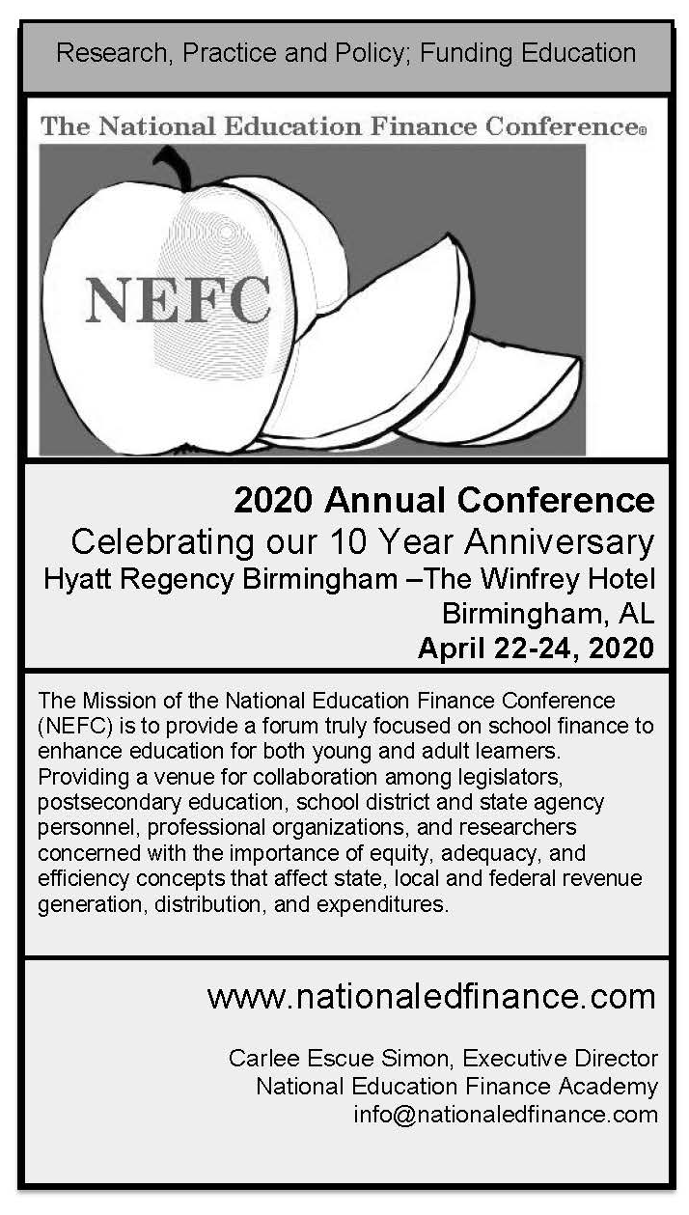

Illinois State University

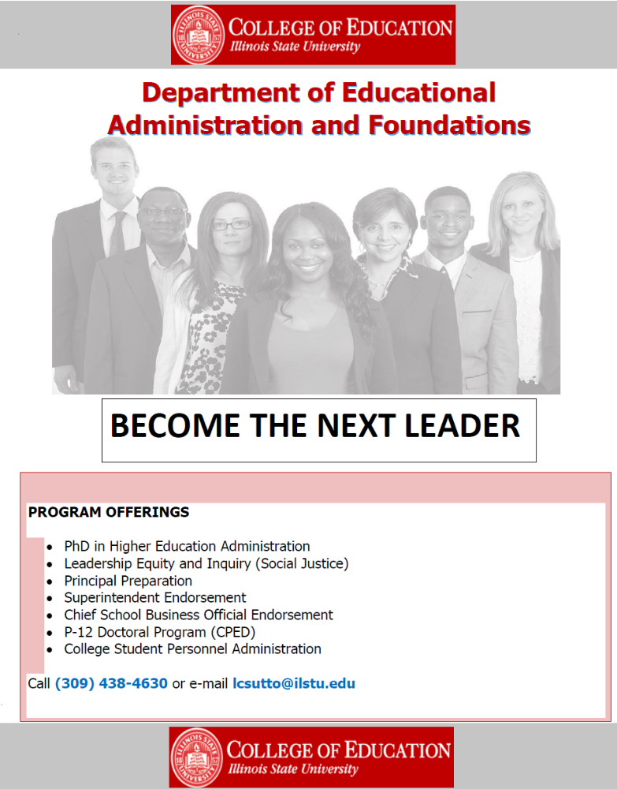

Old Dominion University
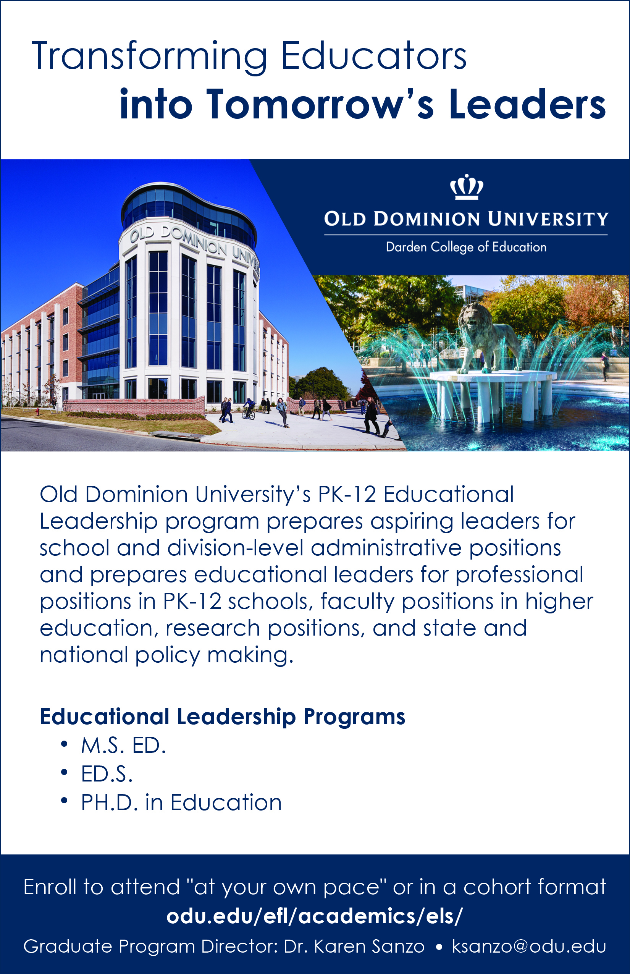
Stetson University

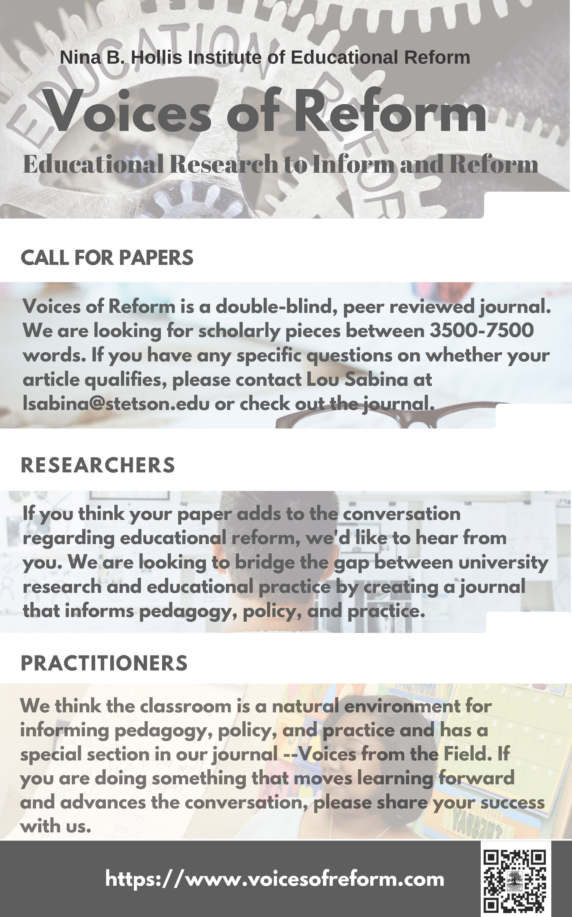

University of North Carolina at Chapel Hill
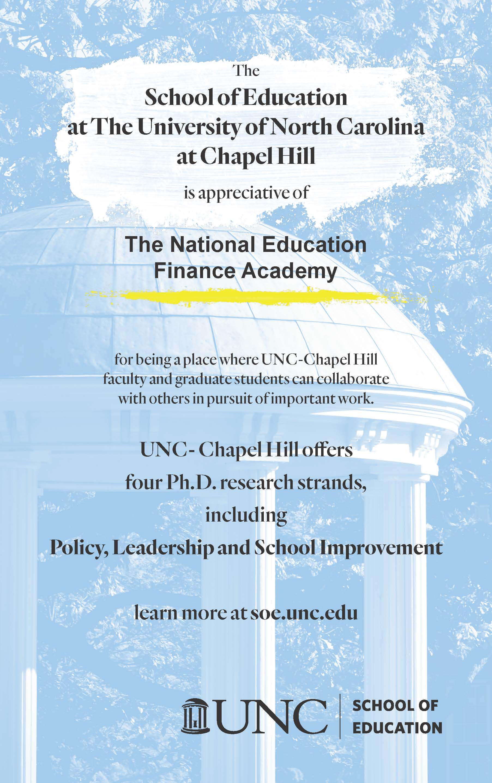
University of South Florida


University of Rhode Island
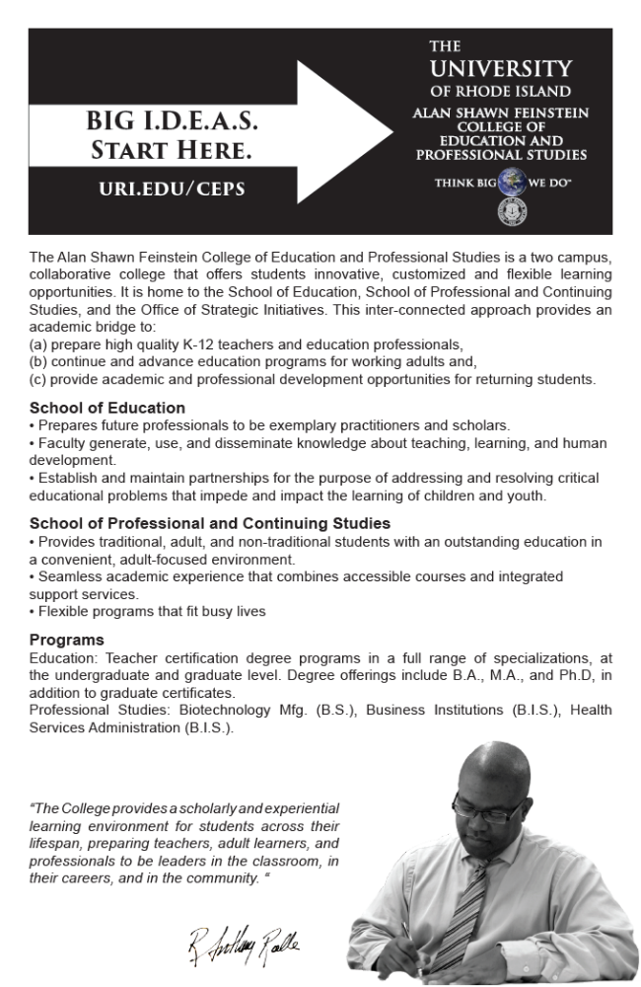
University of Tennessee
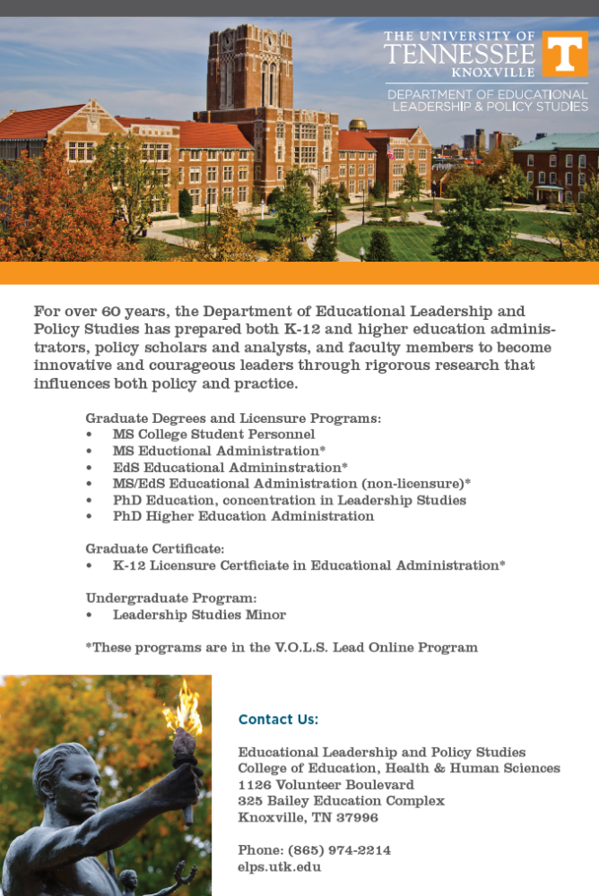
Hotel Map

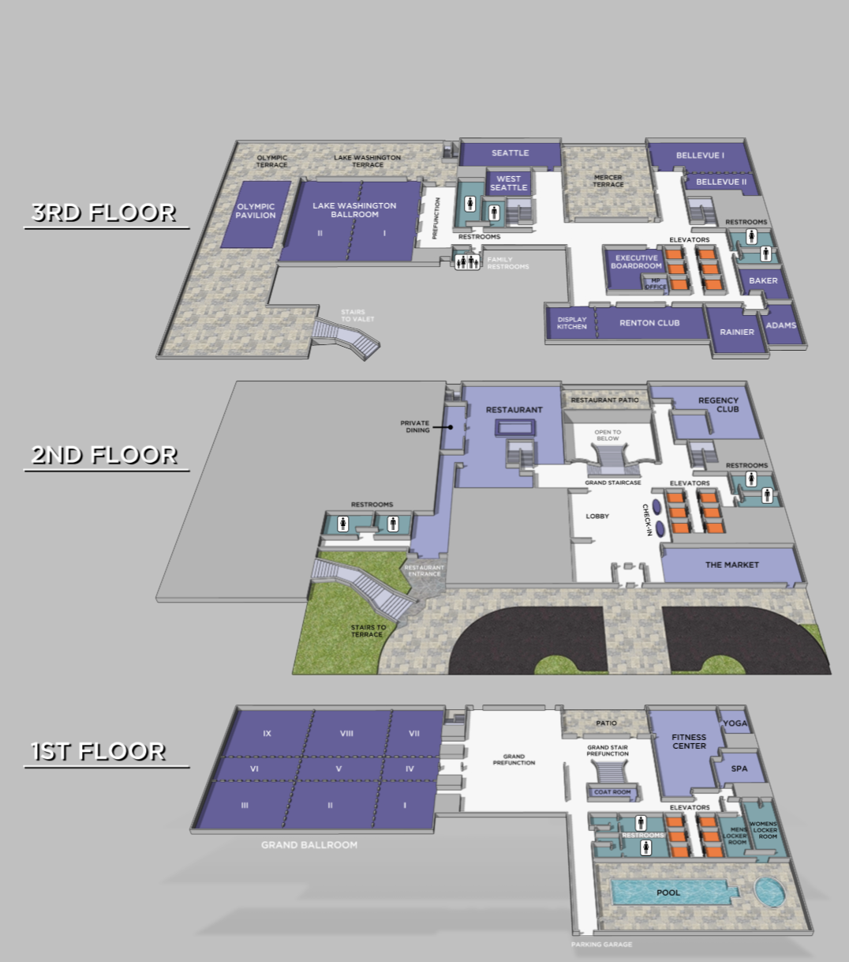
Index

Adams, Venice 10
Alexander, David 29
Alexander, Kern 12
Alexander, Nicola A. 1, 7, 10, 12, 19, 21, 27
Allen, Delia B. 5
Anderson, Jeremy 11
Anglum, J. Cameron 10, 24
Assemien, Bellinda 19
Ayata, Frank 5, 11, 20
Aziz, Mazen 8, 9, 11
Begay, Victor 18
Bendavid-Hadar, Iris 17, 22
Bounds, Steve 9, 15
Bowman, Kristine 25
Buckman, David 10
Byerly, Channa 5, 11
Bynoe, Tyrone 10, 21, 22
Cohen, Joshua M. 23
Cohen, Michael 9, 10
Collins, Linda 17
Cornelius, Luke M. 1, 3, 6
Dagley, Amy 9
Dawn-Fisher, Lisa 1, 13
Denardis, Lesley 10
De Luca, Barbara 1
Driscoll, Lisa G. 1, 11, 12, 15, 17, 29, 33
Ellis, Joann 16, 20
Ferris, Rick 11, 20, 27
Fowler, William J. 12
Friedel, Janice 6, 10, 19, 27
Geier, Brett 10
Ghazzawi, Dina 20
Harris, Pakethia 18
Hart, Walter 10
Helvey, Ken 11
Horn, Catherine L. 20
Houck, Eric 1, 23
Hunt, Amber 16, 20
Jimenez-Castellanos, Oscar 7, 9, 10, 29
Johnson, Arvin 11
Kaplan, Leslie 11, 24
Kelly, Matthew 11, 20, 26
Kim, Hyunjun 21
Kiracofe, Christine Rienstra 8, 9, 10, 16, 23
Knight, David 18, 19, 28
Knoeppel, Robert C. 1, 12, 17, 23
Kopanke, Jason 8, 11, 21, 24
Lacost, Barbara 10
Lopez, Patricia 7
Lyles, Chelsea 10, 19
Maiden, Jeffrey 5, 11, 22
Martinez, David G. 7, 9, 10, 18, 25, 29
Mcclure, Maureen W. 6, 24, 26
Mendiola, Brenda 10, 15
Mendoza, Jesus 18
Milligan, Drew 11
Mohamed, Hoda 6
Morgan, Lee 9, 10 13
Mullin, Christopher 7, 12, 20
Murray, Brittany 23
Neary, Christopher 27
Olerio, John 25, 27
Olofson, Mark 28
Owings, William A. 1, 8, 11, 24
Paige, Mark 24, 28
Parker, Emily 7
Peters, Anna 6, 26
Plecki, Margaret L. 4
Reeping, David 23, 27
Reinhardt, Sara Frakes 8
Reynolds, Tammie 11, 22
Rivera, Marielena 7
Robinson, Dustin 24, 26
Rodriguez, Gloria 19
Rolle, R. Anthony 1, 5, 12, 17, 19, 23, 27, 33
Sabina, Kiara 10
Sabina, Lou L. 6, 10, 26
Schwartz, Brian 17
Serna, Gabriel R. 1, 6, 23, 27
Simon, Carlee Escue 13, 24, 28, 33
Smith, Sharda Jackson 18, 21, 29
Soles, Misty 6
Stedrak, Luke 10
Stoetzer, Alexander 6
Stone, Spencer 10
Sughrue, Jennifer 16, 29
Sutton, Lenford 1, 10
Sweetland, Scott 1, 10
Templeton, Toni 20, 28
Theobald, Neil 4, 11, 16, 23, 27
Thro, William E. 1, 10, 16, 21, 33
Tran, Henry 8, 9, 11, 21, 29
Verstegen, Deborah 10, 23
Vesely, Randy 10
Webber, Clay 26
Weiler, Spencer C. 8, 9, 15, 24, 28
Westbrook, Philip T. 1, 3, 9, 15, 18, 33
Wood, R. Craig 16
Zaken, Osnat 10, 22
Zuschlag, Dirk 25

